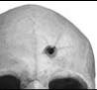
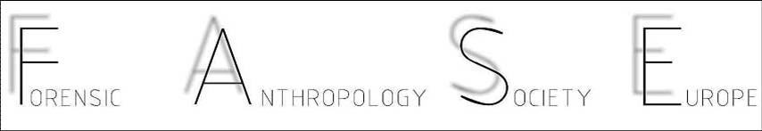
6th FASE WORKSHOP ON FORENSIC ANTHROPOLOGY

Following a tradition of the last decade, the Forensic Anthropology Society of Europe, FASE, is very pleased to announce the organization of a 40 hours course in forensic anthropology in conjunction with the next IALM congress, in Istanbul, just before the meeting.
Advertised here are the main details of the course. We invite you to attend it and to advertise it as largely as possible.
Furthermore we would like to call your attention to the FASE session of the IALM Congress, which will be on the morning of July the 6th with the topic “ Updates in forensic anthropology”. You are very well welcome to submit an abstract on forensic anthropology issues for this session.

We thank you for your cooperation.
See you in Istanbul.
Best wishes
Eugénia Cunha
FASE President
January 2012

6th FASE WORKSHOP ON FORENSIC ANTHROPOLOGY

Place: ISTANBUL, TURKEY, Halic Congress Center
Dates: June the 30th- July the 4th
Duration: 40 hours course ( 8 hours a day)
With certification of attendance
Can give equivalence for 2 ECTS

For more information, please contact Eugénia Cunha, cunhae@ci.uc.pt

6th FASE WORKSHOP ON FORENSIC ANTHROPOLOGY

Program:
Aims of Forensic anthropology in the 21st century
Time elapsed since death
Diagnosis of Species
Excavation of human remains
Biological Profile: sex; age at death; ancestry and morphology
Factors of individualization
Facial approximation
Traumatic injuries.
Cause and manner of death in forensic anthropology
Crimes against humanity and mass disasters
Forensic odontology
Forensic anthropology and the living
Case studies

6th FASE WORKSHOP ON FORENSIC ANTHROPOLOGY
The course includes 15 hours of practical classes

TEACHING STAFF:

Douglas Ubelaker; Cristina Cattaneo, Eugénia Cunha, Eric Baccino, Laurent Martrille, Frank Ramsthaler, Zuzana Obertova

FEES:
As this Course is given in conjunction with the IALM congress, attendees are obliged to register for the IALM congress as well.
The fees, which include 2 coffees breaks, a lunch box and a CD with course material, are as follows:
- FASE students ( students and FASE members simultaneously)- 275 euros
- Students ( not FASE members)- 300 euros
- FASE members ( not students)- 325 euros
- Others- 375 euros

These prices are guaranteed until May the 1st. After that date they will be increased of 10%.

Students: pre-graduation, graduate students, masters’ and PhD students as well as residents.

Payments can be done by BANK TRANSFER to the following account in Portugal:

CENTRO DE ESTUDOS E PÓS GRADUAÇÃO EM MEDICINA LEGAL
Coimbra, Portugal

IBAN PT 500036 003600339910058168688
SWIFT CODE MPIOPTPL

For invoices, please provide complete name, NIF and address

